1)Login as Service agent

2)Create a case for IP

Eg: 37208106

3)Click on the Safety qustions

4)Click on Request a Quote

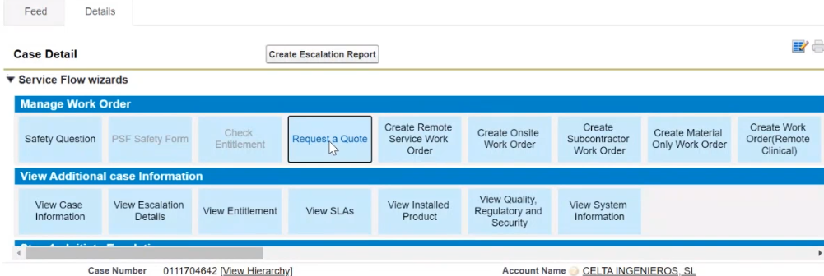

5) change status to Draft

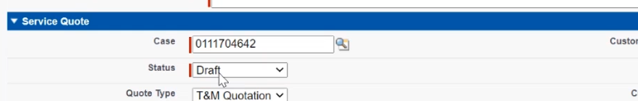

6)Pick any business group

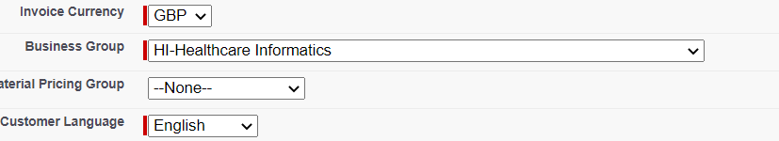

7)Pick any T& C

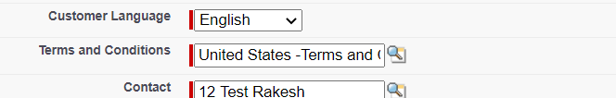

8)if we want part under quote then

Click on New and Search for the product which you want . & fill the mandatory fields

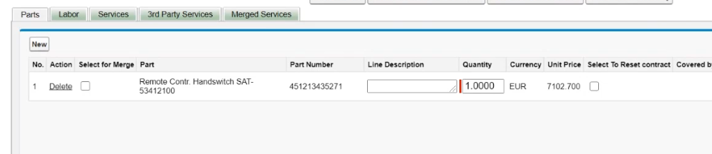

9)Click on the labor & new

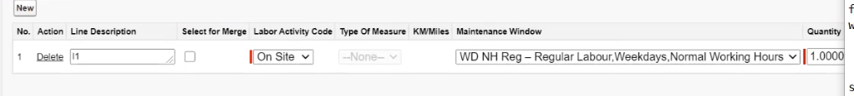

Click on the Get Price /VAT

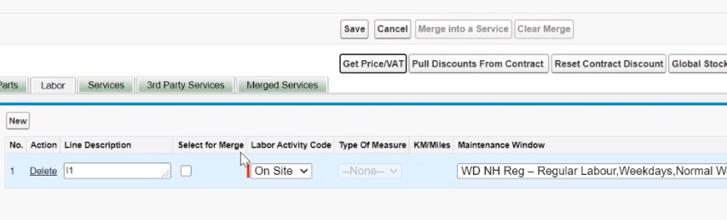

Verify the success message

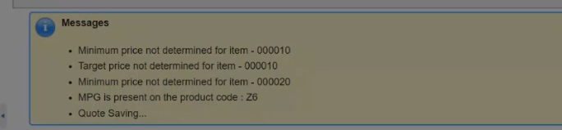

IF we get the error message then , the data is not managed for the Account & Product in SAP.

All the data will populated based on the material & group , salesorg and Account

10)Click on Done

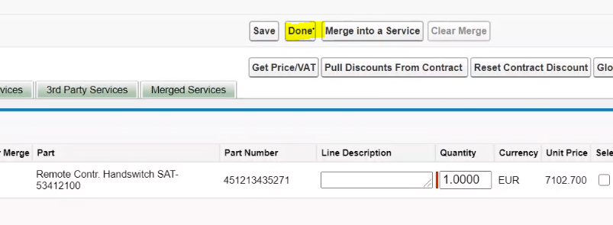

11)Click on the Release Quote

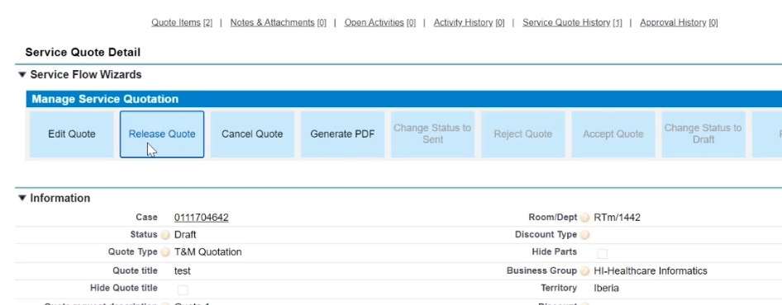

If Quote is met the criteria , then quote is Auto approved internally . and check the quote status as approved .

To change the status to internally approved , it will take max 5 mits & not more that.

12)Click on the Accept Quote .

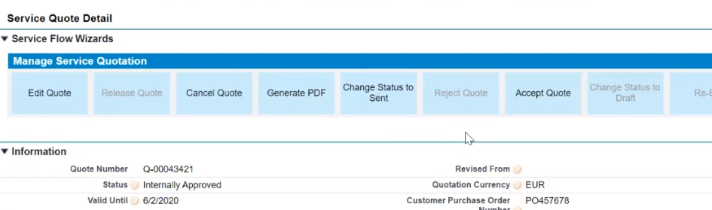

Provide any unique number & Click on Save.

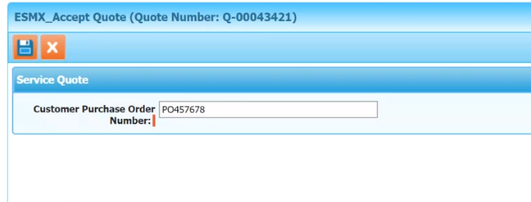

13)Verify the SAP Debit memo number is generated .

